JAIWIN MITHRA A/L SURANDRAN

Adaptable team player with experience in task coordination
and thriving in fast-paced environments. Skilled in attention
to detail and effective collaboration.

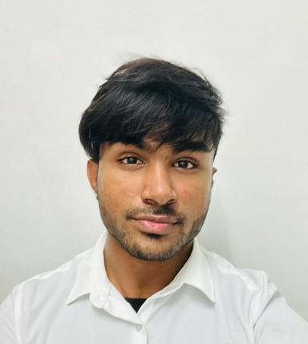





+601126132794
jaiwin005@gmail.com
www.linkedin.com/in/jaiwin-mithra
67, Lintang Lembah Permai 1, Tanjung Bungah, 11200, Pulau Pinang, Malaysia

SOFT SKILLS
LEADERSHIP COMMUNICATION TIME MANAGEMENT ADAPTABILITY PROBLEM SOLVING

TECHNICAL SKILLS
HTML CSS
JAVASCRIPT PHP
C PROGRAMMING PYTHON
MS OFFICE MICROSOFT EXCEL CANVA

QUALIFICATION
Tunku Abdul Rahman University of Management and Technology, Penang, Malaysia
2023 - Present
Currently pursuing Diploma in Information Technology
SMK Bagan Serai
2018 - 2022

ACHIEVEMENTS & AWARDS
Tunku Abdul Rahman University of Management and Technology, Penang, Malaysia
TARUMT x GradMalaysia
- Co-organized the Skill Enhancement Module 2024.

Wellness Campaign 2024
- Assistant Head of IT, managing technical requirements and overseeing digital setup.

Indian Cultural Day 2024
- Co-organized the event and served as a key leader.

Penang Goes Orange 2023
- Provided IT support to ensure smooth technology operations during the event.
- Directed and edited event videos.

Team Building 2023 - Team Thrive Unite
- Served as Student Leader, guiding team activities and promoting collaboration.

EXPERIENCE
LANGUAGE ABILITIES
ENGLISH
BAHASA MALAYSIA TAMIL INDONESIAN
HOBBIES
- WORKING OUT
- CYCLING
- HIKING
- PHOTOGRAPHY
- COMPUTER PROGRAMMING
References

Ms. Hanyusha
Relationship: Business Associate
Phone Number: 010-802 4445

Ms. Hanyusha
Relationship: Business Associate
Phone Number: 010-802 4445

Mr. Narresh
Relationship: Team Member
Phone Number: 016-504 5678

JAIWIN MITHRA A/L SURANDRAN

Business Social Media Management (2024 - present)
  - Experienced in product development in
watch Modifications.
  - Social media management for brand growth
and engagement.
  - Content planning and creation.

Swaranjali 2024
  - Marketing for Cultural Music Concert (Swaranjali 2024) in collaboration with Episode Events.
  - Perform ticket sales and managed social media.

E-Commerce Website (2023)
  - Language: HTML, CSS, JavaScript
  - Project Duration: 3 months
  - Content: Developed a website focused on jewelry products.

Client-Server Web Application (2023)
  - Language: HTML, CSS, JavaScript, PHP
  - Project Duration: 3 Months
  - Content: Developed a web application with client-side and server-side scripting

MS SOOK FONG CHO
Relationship: Lecturer
Email: chosf@tarc.edu.my

